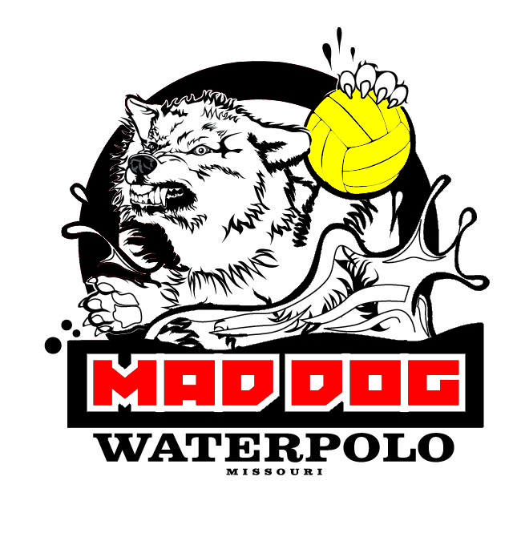
Mad Dog Water Polo – Player Information Form
Please call theCcach Emde with questions
(This form should be completed and returned to Coach Emde)

Player Name

________________________, ___________________________
Last First

Birth Date _____/______/________ Grade ________

Parents’ Name

___________________ ________________________
Mother’s Name Father’s Name

e-mail address ____________________________________________

Address:
_______________________________________________
_______________________________________________
_______________________________________________

Phone Number: ( ) ______-___________
Work Phone ( ) ______-___________
Cell Phone ( ) ______-___________
e-mail __________________________________________
alternate e-mail ______________________________________

High School ________________________ Fr So Jr Sr
(Circle One)

Number of years playing water polo? ________________

Number of years swimming? _______________

Primary Position: Driver 2 meter 2 md Utility Goalie
(Circle one)

Right or left handed? ______________

Please mail this form or bring to the first practice to sign up. US Water Polo registration must also be completed. Other forms are required.

MAIL TO (With Check made payable to MDWP & Waiver):
Gregg Emde (MDWP)
635 Spring Meadows Drive
Ballwin, MO 63011

