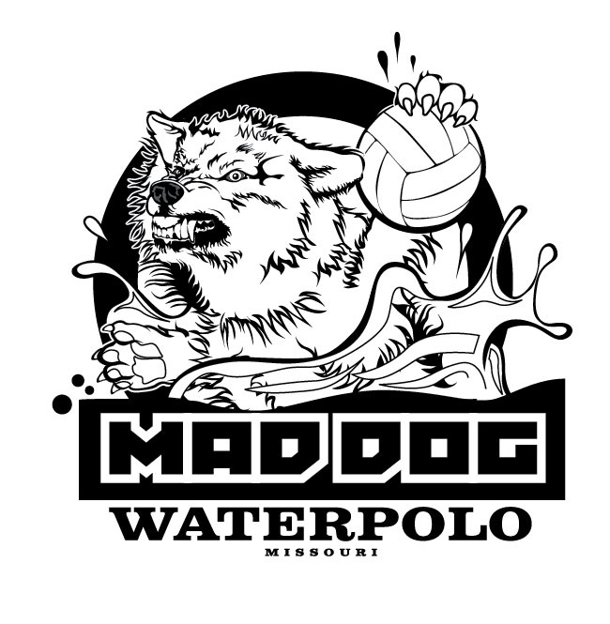

WAIVER, RELEASE OF LIABILITY AND HOLD HARMLESS AGREEMENT
MINOR PARTICIPANTS
(Participants under 18)

I am the parent or legal guardian of __________________________ (“Minor”), who has enrolled in the Mad Dog Water Polo program identified below.

In return for the Minor being accepted into the Mad Dog Water Polo offered by the company (“Mad Dog Water Polo” or MDWP). I:

- Acknowledge that I understand the nature of the program, and believe that Minor is qualified and in proper physical condition to participate in the Program. I further agree that if at any time, I or Minor believes conditions to be unsafe with respect to Minor’s physical condition, the equipment, or facilities, it shall be Minor’s responsibility to, and Minor will, immediately discontinue participation in the Program.

- Further acknowledge that the program involves the risk of serious bodily injury (including the possibility of permanent disability, paralysis, or death), which may be caused by (a) Minor’s own actions or inactions, (b) the actions or inactions of others participating in the program, (c) the condition of the equipment and/or facilities at which the Program is located, or (d) the actions or inactions of the entities and persons identified below; and fully accept and assume all such risk and all responsibility for losses, costs, and damages Minor may incur as a result of Minor’s participation in the Program.

- Accordingly, I herby release MDWP, together with its directors, officers, employees, volunteers and agents from all liability, claims, demands, losses, or damages arising out of Minor’s participation in the Program; and further agree that if, despite this release and waiver of liability agreement I, the Minor, or anyone on behalf of the Minor or myself, makes a claim released in this agreement, I will indemnify and hold harmless each entity and person released herein from any and all litigation expenses, attorney fees, loss, liability, damage, or the cost they may incur as the result of such claim.

I have read this agreement, fully understand its terms, and have voluntarily entered into this agreement of my own free will based only upon the terms and conditions included herein.

Printed Name of Parent/Guardian

Address (street)(city)(state)(zip)

Telephone number (work) (home) (cell)

Parent/Guardian signature (only if participant is under the age of 18)

____________________
Date

